Medical Messenger - Project Brief

SWE40006 - Software Deployment and Evolution

Group 5:

Dang Khoa Le - 103844421

Joell Rajasingham - 103101032

Lakshan Herath - 104197003

Toran Kumar Behera - 103821851

Table of Contents
Background of the Project 3
Selected tools and their justification 3
1. Project Description 3
1.1 Goals & Users 3
1.2 Core Functional Requirements (MVP) 3
1.3 Non-Functional Requirements 4
2. High-Level Architecture 4
2.1 System Context 4
2.2 Minimal Data Model Schema 6
3. DevOps Server Pipeline and Deployment 6
3.1 Environments & Branching 6
3.2 CI/CD (GitHub Actions) 6
3.3 Configuration & Secrets 6
3.4 Observability & Quality Gates 7
4. Security & Privacy 7
5. MVP Release 7
Success Metrics 10
1. Stable Development Process 10
Project Goals 10
Implementation Plan 10
2. Fast and Reliability 10
Project Goals 10
Implementation Plan 11
3. User Data and Privacy 11
Project Goals 11
Implementation Plan 11
Project Scope and Exclusions 12
1. Scope 12
2. Exclusions 13
Project Deliverables 14
Team Distributions 15
References 16

Background of the Project
This project delivers a medical messenger that enables patients to discover and subscribe to doctors across common specialties (e.g., physician, psychology, ENT, pulmonology), and exchange private, real-time messages. The solution is intentionally modest to ease implementation and support a smooth DevOps pipeline on Azure.
Technology stacks:
- Frontend / Full-stack framework: Next.js (React), shadcn/ui, Tailwind CSS
- Real-time messaging: Socket.IO (WebSockets) within the Next.js app [6]
- Data store: MongoDB Atlas (starter free tier for development) [4], [5]
- Hosting: Azure App Service (Linux) [7]
- Observability: Azure Monitor – Application Insights [3]
- Secrets: Azure Key Vault (referenced from App Service) [2]
- CI/CD: GitHub Actions → Azure App Service [1], [13]

Selected tools and their justification

1. Project Description

1.1 Goals & Users
- Patients: search and filter doctors by name/specialty; request subscription; chat 1:1 once approved from the doctor.
- Doctors: maintain profile & specialties; approve subscriptions; chat privately with subscribed patients.
- Admin (lightweight): basic user moderation and audit log access.

1.2 Core Functional Requirements (MVP)
- Doctor Directory & Subscription
  - Search by name and specialty tags.
  - Subscribe request flow; doctor can approve/deny.
  - Minimal profile (name, role, specialties, short bio).
- Private 1:1 Chat
  - Real-time text messaging (Socket.IO over WebSockets) [6].
  - Message persistence in MongoDB (sender, recipient, timestamp, body, status).
  - Basic delivery status (sent/received) and online presence indicator (simple).

- Accounts & Access
  - Email/password sign-up with password hashing (bcrypt) following OWASP recommendations [8].
  - Session-based auth (Next.js API routes) and route protection (patient vs doctor).
  - Minimal consent notice prior to subscription (patient-facing).
- Privacy & Consent
  - Patients must accept a consent notice before subscribing to a doctor. Data use aligns with Australian Privacy Principles (APPs) [10], [11].
- Security Requirements:
- Passwords are hashed (bcrypt); never stored in plaintext.
- Transport security via HTTPS/TLS (enforced by Azure App Service).
- Message content stored server-side; if future requirements demand stronger confidentiality, add application-layer encryption for message bodies (e.g., AES-GCM with authenticated encryption) and managed keys via Key Vault [2].

1.3 Non-Functional Requirements
- Simplicity first: single App Service app (monolith) with Socket.IO in the same codebase.
- Availability & scale (early): single instance with the option to scale out; sticky sessions enabled [7] when using Socket.IO .
- Performance target: p95 message round-trip under 400 ms in-region for MVP.
- Observability: server logs plus Application Insights traces and basic dashboards [3].
- Privacy: treat all chat content as health information; capture consent for doctor–patient pairing; provide a visible link for data access/correction requests.

2. High-Level Architecture

2.1 System Context
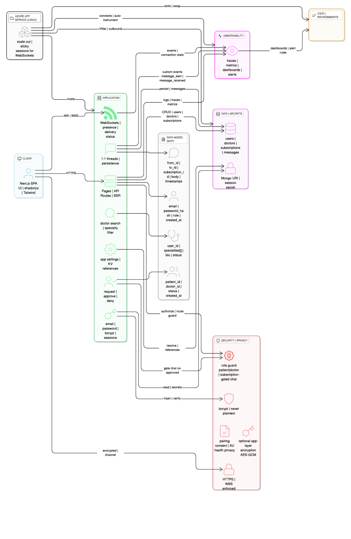
Figure 1. Project architecture design
Key designs:
- One deployable (Next.js server) hosts both REST APIs and Socket.IO for real-time messaging.
- MongoDB Atlas handles user, doctor, subscription, and message collections.
- Key Vault supplies secrets (DB URI, session secret) via App Service Key Vault references.
- Application Insights collects logs/metrics/traces.

2.2 Minimal Data Model Schema
- users (common): _id, email, password_hash, role ∈ {patient, doctor}, created_at
- doctors: _id (ref users), specialties[], bio, status
- subscriptions: _id, patient_id, doctor_id, status ∈ {requested, approved, denied}, created_at
- messages: _id, from_user_id, to_user_id, subscription_id, body, created_at, delivered_at?

3. DevOps Server Pipeline and Deployment

3.1 Environments & Branching
- Git branches: main (production), develop (staging), feature branches → PRs.
- Azure App Service: Production app with Staging slot for pre-prod validation.
- MongoDB Atlas: One dev cluster (M0 free tier), one prod cluster (paid tier when needed).

3.2 CI/CD (GitHub Actions)
- CI on PRs [1], [13]: install deps → build → lint/type-check → unit tests.
- CD on develop: deploy artifact to Staging slot → smoke tests.
- CD on main: after staging approval, swap Staging → Production [7].
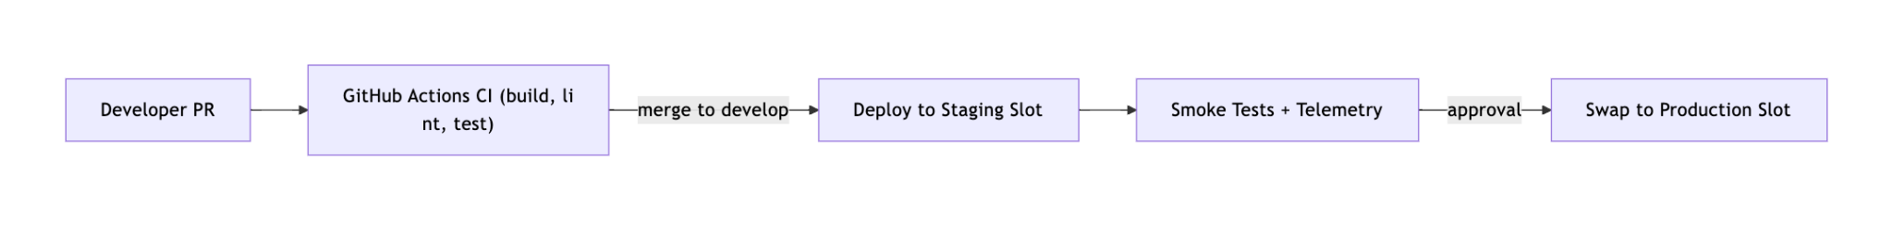
Figure 2. Project CI/CD workflow

3.3 Configuration & Secrets
- App settings hold non-sensitive config (e.g., NODE_ENV, feature flags).
- Key Vault references supply sensitive values (MongoDB URI, session secret) [2].
- App uses a managed identity or service principal for Key Vault access.

3.4 Observability & Quality Gates
- Application Insights SDK added to the Next.js server to track request rates, response time, failures, and custom events (e.g., message_sent, message_received) [3].
- Dashboards & alerts: basic alert on error rate spike; manual check on staging before swap

4. Security & Privacy
- Passwords: stored using bcrypt (adequate cost factor); no reversible storage [8].
- Transport: HTTPS (TLS) enforced end-to-end [9].
- At rest: database managed encryption by provider; consider app-layer encryption for message bodies if/when policy requires stronger confidentiality [4].
- Access control: role checks on API (patient/doctor), subscription status gating chat access.
- Consent & APPs alignment (AU): inform patients what is stored and why; provide a visible link for access/correction; restrict disclosure to treating doctor; secure storage; document retention and deletion routines (aligns with the OAIC Guide to Health Privacy [10]).

5. MVP Release
- CI green (build/lint/tests).
- Staging deploy passes smoke tests [3]; Application Insights shows stable error rate and p95 latency.
- Key Vault references configured; no secrets in repo or plain app settings [2].
- Minimal privacy notice and consent step live; audit log records subscription approvals.
- Production swap executed; rollback plan validated (slot swap back) [7].

Project Goals and Objectives
Our objective for this project is to plan and develop a DevOps tool chain and server pipeline. The application we are developing is going to be a messaging application that allows patients to message doctors. This project is to demonstrate our understanding of the software lifecycle, particularly deployment.
First, we decided to split the group into frontend and backend so that we can make progress on both fronts. As this project has been divided into levels 1-4 we will use this as a guide for our milestones:
Level 1: Create a simple DevOps pipeline including a code repository server, a CI/build server, a test server, and a production server.
Level 2: Complete task 1 and add instrumentation to the production server, which can gather stats on server performance.
Level 3: Complete task 2 and deploy a simple application using the DevOps pipeline. Verify that your application works accurately and is accessible.
Level 4: Complete task 3 and test the automation scripts by changing the source code to trigger a deferred or automatic deployment of the new build.
We are going to be aiming for level 4 and our selected tools for this project are as follows:
- NextJS: This application will be a full NextJS application, as both frontend and backend will be in NextJS. This is a very easy to use and developed framework that allows both frontend and backend functionalities to be in one codebase.
- Shadcn and Tailwind: These two will be used for the CSS styling and overall appearance of the application and integrates well with React. This decision was made based on the fact that we decided to use NextJS for this application.
- Socket.io: We will be using Socket.IO over Websocksets as it allows for real time two-way communication between clients and server which is important for our application. This tool can handle event based communication, connection reliability and automatic reconnection.
- MongoDB: We decided to use Mongo DB for our database as it supports NoSQL and its free tier subscription will be useful for this project. This is because it reduces how many paid services we need to manage.
- Azure: Our choice of App Service will be Azure as our production server for a few reasons. It is an easy to use service and also one of the cheapest. Furthermore, it has many features and tools that we can use for this application and its compatibility with Next JS runtime will make things smoother.
- Github Actions: Is our selected form of continuous integration and continuous deployment, as it is capable of automating the build, test and deployment pipeline from the repository. It also integrates with Azure very smoothly.
- Azure Monitor: To provide real-time monitoring, performance analytics and logging for our application once deployed, we will use Azure Monitor to ensure our application is running sufficiently and maintaining uptime and reliability, it can track data response times, request rates, and errors. We decided to use this tool as it is in-built within Azure.
- Bcrypt: For password hashing and security we will use bcrypt, as if this application was used in the real world, the information being transferred between the patients and doctors will be incredibly sensitive.

Success Metrics
To ensure this project is a success, we need to measure how well the software is built, how it performs for the users and whether it’s useful and secure. Below mentioned are the key goals and how we plan to track those goals.

1. Stable Development Process
To ensure that the app is fully functional, the development process should be successful. The team goal is to release new features and fix issues quickly without breaking the app. To do this, a few industry-standard requirements should be tracked.

Project Goals
- The team aims to release meaningful updates to the app at least once a week while developing it.
- The team wants fewer than 20% of the updates to cause any issues that require an emergency fix.
- The time taken for a new piece of code to go from the developer’s machine to the live app should be less than 5 hours.

Implementation Plan
- GitHub Actions are used to create an automated pipeline. Each time a developer submits the code, it will be automatically built, checked for errors and tested. This prevents bugs from reaching the live application[1], [13].
- Instead of deploying updates straight to the public, it is sent to a private “staging” area first. This is an exact copy of the live environment where testing can be done safely[7].
- Consistent Setups with the code are actioned. The team will define the entire server setup in code using Bicep templates. This means that the testing and live environments will always be identical.
- Before an update is made live, a final check will be done in the dashboard in Azure Application insights. This dashboard will show the app’s health and if all signals are green the team proceeds[3].

2. Fast and Reliability
For an app such as a Medical Messenger, it needs to be available at all times and feel fast and responsive.

Project Goals
- The team targets 99% uptime which means that the service should be available virtually all the time.
- When a user clicks something, it should feel instant. The team wants to ensure that for 95 out of 100 requests, the response time is under half a second.
- The core of the app is messaging. A message should feel like it appears on the other person’s screen the moment it’s sent. The team aims this to take less than 1 second[6].
- The team expects to keep server errors to a bare minimum which aims to be fewer than 1 in every 200 requests.

Implementation Plan
- Plugging the app into Azure Application Insights which will be the central dashboard for monitoring the app’s health in real time[3].
- To ensure the chat is fast enough, adding custom tracking to time how long it takes fora message to travel from sender to receiver.
- Setting up alerts in Azure Monitor to automatically notify the team if the app becomes slow or if the error rate starts to climb[3].
- The app is built on Azure App Service which lets you easily add more server power. For the chat service, the team will ensure that users stay connected to the same server to avoid interruptions during conversations[7].

3. User Data and Privacy
Given the sensitive nature of medical conversations, security and privacy are high priorities.

Project Goals
- Ensuring that sensitive information such as database passwords and secret keys are not stored in the code repository.
- All passwords will be securely stored using modern hashing techniques(bcrypt)[8]. The team will also build strict rules to ensure a user can only ever see their own data and conversations.
- The team will operate with a “privacy by design” mindset, ensuring every feature is compliant with the Australian Privacy Principles[10], [11].

Implementation Plan
- The team plans to use Azure Key Vault, a secure and managed service from Microsoft to store all the application secrets. The app will be given permission to retrieve them securely at runtime without anyone seeing them[2].
- Before launching, the team plans to perform a thorough manual security review. Finding and fixing common vulnerabilities, paying special attention to making sure one patient could never accidentally access another’s chat history[9].
- Every critical action, especially when a patient gives consent to connect with a doctor, will be securely logged. This creates a permanent record that is essential for security and compliance[10].

Project Scope and Exclusions
This project is developed within a limited timeframe for a course that emphasizes software deployment rather than extensive feature development. The final deliverable is intended to be a Minimum Viable Product (MVP) that demonstrates the application’s core functionality to a sufficient level. Consequently, the project scope has been carefully defined to balance ambition with feasibility – focusing on essential features that ensure a functional and deployable solution, while deliberately excluding less critical aspects of the web application.

1. Scope
The following items are within the scope of the project:

Doctor Directory and Subscription System
- Patients can search for doctors by name or specialty.
- All common medical specialties will be accounted for.
- Subscription requests can be initiated by patients and approved or denied by doctors.
- Each doctor profile includes basic details such as name, specialty, and short biography.
Private Messaging System
- Real-time one-to-one messaging between approved doctor–patient pairs using Socket.IO over WebSockets [6].
- Message persistence with timestamps and delivery status stored in MongoDB [4].
- Online/offline status indicator for active users.
User Accounts and Authentication
- Role-based access for patients, doctors, and administrators.
- Secure user authentication via email and password, with password hashing following OWASP guidelines [8].
- Session-based authorization and protected routes.
- Basic cryptographic storage practices follow OWASP recommendations [9].
Deployment and DevOps Pipeline
- Automated CI/CD pipeline using GitHub Actions for build, test, and deploy stages [1].
- Deployment to Azure App Service (Linux) with separate staging and production environments [7].
- Infrastructure configuration and secret management using Azure Key Vault [2].
Monitoring and Observability
- Integration of Azure Application Insights for performance metrics, request tracking, and error monitoring [3].
- Alerts and dashboards to visualize application health, uptime, and latency.

2. Exclusions
The following items are explicitly out of scope for this project:
Application Features
- Group messaging functionality.
- Inclusion of less common or highly specialized medical fields.
- Voice or video calling features.
- Integration with external healthcare systems.
- Core functionality for anonymous or guest users.
Technical and Architectural Limitations
- Use of a separate backend framework for APIs (Next.js’ built-in backend capabilities are sufficient).
- Implementation of advanced scalability or load-balancing solutions.
- Use of complex architectural patterns or tools such as Redux or microservices.
- Development of AI–based features.
Business and Deployment Restrictions
- Publishing the system for commercial or public use.
- Inclusion of monetization features or payment processing.
Documentation and Compliance
- Production of detailed technical documentation for setup, deployment, and maintenance.
- Development of privacy and consent documentation in alignment with OAIC health data guidelines [10], [11].
- Implementation of consent prompts or workflows aligning with the Australian Privacy Principles (APPs) [11].
- Advanced data security mechanisms beyond the project’s basic scope (e.g., end-to-end encryption or audit trails).

Project Deliverables
The project deliverables outline the key outputs that will be produced upon completion. Each deliverable has been designed to demonstrate the project’s functionality, technical soundness, and alignment with deployment-focused objectives. Together, they encompass the project’s development and deployment efforts, providing both a functional solution and the supporting materials necessary for evaluation and presentation.
The following deliverables will be produced and submitted as part of the project completion:
Functional Web Application
- A fully working web app deployed on Azure App Service [1], [7].
- Includes core functionalities: doctor search, subscription flow, and real-time messaging [6].
- Accessible via secure HTTPS endpoint with role-based access control [8], [9].
Source Code Repository
- Complete, well-structured GitHub repository with clear folder organization for frontend, backend, and infrastructure.
- Automated GitHub Actions workflow for CI/CD, linting, and unit tests [1], [13].
Database Schema and Configuration
- MongoDB Atlas database with defined collections for users, doctors, subscriptions, and messages [4], [5].
- Documentation describing schema relationships, indexes, and data validation.
DevOps Pipeline and Infrastructure Documentation
- CI/CD pipeline configuration (GitHub Actions YAML files) [13].
- Azure App Service deployment setup, environment variables, and Key Vault integration [2].
Observability and Monitoring Setup
- Configured Azure Application Insights dashboard displaying latency, request count, and error metrics [3].
- Alerts set up for downtime, errors, etc.
Final Report and Presentation
- Formal written report detailing the background, design, implementation, and evaluation of the system.
- Presentation slides summarizing project objectives, features, architecture, and results.
- Demonstration video (if required) showing core functionalities and DevOps pipeline operation.

Team Distributions

Time | Activities | Dang Khoa Le | Joell Rajasingham | Member B | Toran Kumar Behera
Week 1 | Foundation & Setup | Orient the team, clarify requirements,confirm MVP scope.  Setup repo structure (frontend/backend/infra folders).  Configure Azure Resource Group + App Service initial skeleton.  Oversee security checklist (bcrypt, TLS, Key Vault plan). | -Setup Next.js frontend skeleton with shadcn/ui & Tailwind.  Implement landing page + basic routing. | Setup MongoDB Atlas free cluster.  Create initial schemas: users, doctors, subscriptions, messages.  Seed with mock data for dev. | Setup GitHub Actions CI pipeline: build, lint, test workflow.  Create initial docs on CI pipeline usage.
Week 2 | Core Features Development | Lead design of subscription & chat workflow.  Pair program on core APIs (chat + subscription).  Verify integration between Next.js → MongoDB → Socket.IO | Implement doctor search & subscription request UI.  Wire subscription request to API.  Add basic consent notice UI. | Implement API routes for subscription request, approve, deny.  Implement chat message persistence (MongoDB → messages collection). | Implement Socket.IO setup in Next.js server.  Add basic 1:1 chat UI with real-time updates.  Ensure WebSocket connectivity in staging.
Week 3 | Testing, Deployment & Observatory | Conduct end-to-end testing (patient ↔ doctor chat, subscription flow).  Finalize privacy compliance statement + documentation.  Oversee staging deployment, production swap. | Conduct UI testing & bug fixing.  Add user-friendly error messages & loading states.  Prepare screenshots for report. | Write unit tests for API routes (subscription, messages).  Add DB validation (required fields, indexes). | Finalize CD pipeline (staging slot + prod swap).  Integrate Application Insights SDK.  Configure dashboards & alerts.

References
[1] GitHub Docs, “Deploying Node.js to Azure App Service with GitHub Actions,” 2025. GitHub Docs
[2] Microsoft Learn, “Use Key Vault references as App Settings (Azure App Service),” Sep. 2025. Microsoft Learn
[3] Microsoft Docs (Azure Monitor), “Monitor Node.js applications with Application Insights,” 2025. Microsoft Learn
[4] MongoDB Docs, “Atlas M0 (Free Cluster) limits,” 2025. MongoDB
[5] MongoDB, “Pricing — Atlas Free Tier (M0) overview,” 2025. MongoDB
[6] Socket.IO Documentation, “Introduction to Socket.IO (v4),” 2024+. socket.io
[7] Azure App Service (Linux) Community Docs, “How to use WebSockets with Node.js in App Service,” 2023+. GitHub
[8] OWASP, “Password Storage Cheat Sheet,” 2025. OWASP Cheat Sheet Series
[9] OWASP, “Cryptographic Storage Cheat Sheet,” 2025. OWASP Cheat Sheet Series
[10] OAIC, “Guide to Health Privacy,” May 2025. OAIC
[11] OAIC, “Australian Privacy Principles Guidelines,” Dec. 2022. OAIC
[12] Node.js, “WebSocket (Getting Started),” 2025. Node.js
[13] Microsoft Learn, “Deploy to Azure App Service by using GitHub Actions,” Mar. 2025. Microsoft Learn

